**SANJAY. V**,

4/9, KOTHANDHAM STREET,

WEST JONES ROAD,

SEKAR NAGER, WEST SAIDAPET,

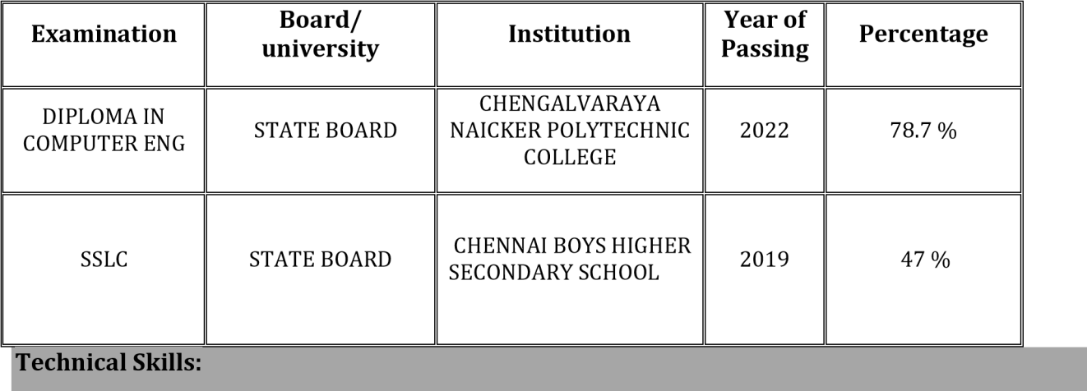

CHENNAI-600083

Email id:MASSSANJAY1322@gmail.com Mobile No : +91-9344191127

**Career Objective**

Aspire to work in an organization which offers me a work environment with tough & challenging opportunities, enabling to improve my technical, leadership skills and also to contribute to growth of the organization to best of my abilities.

**Academic**  **profile:**

* Operating system: Windows OS (Win XP, Win 7, Win 8, Win 10).
* Remote Support: Team Viewer, Any Desk for giving Desktop support for user.
* Knowledge on Networking:OSI Layers, IPV4, Subnetting, Configuration of LAN.

**Completion:**

* Completed Hardware and Networking course on **CSC Computer Education – Chennai**

**Technical Skills:**

* Hardware Installation, Repair and Maintenance.
* Assembling and troubleshooting all kinds of PC.
* Managing Active Directory users, groups, & polices.
* Create User accounts using active directory services.
* MS outlook 2010, 13&16 and troubleshooting issues, regular data & mail backup of MS outlook

(PST files).

* Installation of OS - Windows 7, Windows 8.1 and Windows 10.
* SonicWALL Firewall VPN Configuration.
* Troubleshooting network connectivity in a LAN/WAN environment.
* Having knowledge about TCP/IP, SMTP, POP3, IMAP,
* Having knowledge on how to Configure IP, DNS and DHCP.
* Hardware Troubleshooting, System Performance, Assembling of new systems.
* Antivirus software and update the antivirus on regular basis and scanning systems.
* Configuring network and local printer.
* Troubleshooting OS related and booting related issues.
* Troubleshooting user profile and Windows login issues.
* Using Remote Tool to take full control of the user system to resolve the queries.

**Personal Profile**

**Father’s Name :** K. VELAYUTHAM

**Date of birth :** 01/03/2002

**Gender :** MALE

**Marital Status :** SINGLE

**Linguistic proficiency :** ENGLISH,TAMIL.

**Declaration:**

I hereby declare that all the details in the application are true, complete and correct to the best of my knowledge and belief**.**

**Place: Chennai (SANJAY. V)**

**Date :**